LLD_Gaming_PoC Release 3.0.13

Low latency Data Transfer on QM35 EVB
Also includes FiRa ranging demo
Contents
Firmware Revision History 2
Getting Started 3
Required Hardware 3
Building The Firmware 3
Build Environment Setup 3
Building QM35 Polaris Zephyr Project 3
Flashing QM35 EVB 3
UART Connection 5
Command Menu 6
Low Latency Data 7
Low Latency Data Transfer – using Internal App 7
TX Demo, single side transmission 8
TX Demo, dual side transmission 8
TX Demo with Two Devices 9
Connection without Data Transfer Demo 10
Frame Structure Modifications 10
￼Low Latency Data Transfer – using UCI 11
Application-Application Latency Testing 13
Time Synchronization Testing 13
Statistics Information 16
Low Latency Data Transfer - source code organization 18
Key files on application side 18
Key files on the MAC side 18
TX Power Setting 18
RSSI Reports 20
FiRa 21
Initiating FiRa ranging 21
Initiating FiRa ranging with Data Transfer 22
UCI and FiRa Ranging 23

Firmware Revision History
Release 3.0.13 | - Release contains two images, one that supports one device and one to support two devices. See Section TX Demo with Two Devices below on how to use the two-device image.  - Removed Ping Pong mode (replaced by TX capability on coordinator side  - Both Coordinator and Device can now do TX independently  - Fix UCI issue  - Known Issues:  - Due to overclocking the two-device image potentially can become non-responsive. If this occurs, then the board should be reset.  - The throughput calculation in the two-device image will be wrong due to overclocking time calculation error.  - The throughput when the coordinator is operating in TX mode is half the speed than the device
Release 3.0.10 | - Release contains two images, one that supports one device and one to support two devices. See Section TX Demo with Two Devices below on how to use the two-device image.  - Block/Slot durations and retry sub-block count now configurable through DATAC/DATAD command line options  - Added ADDR command line option to DATAD command to specify device address for multiple device image  - Reduced block duration to 2ms  - Known Issues:  - Due to overclocking the two-device image potentially can become non-responsive. If this occurs, then the board should be reset.  - The throughput calculation in the two-device image will be wrong due to overclocking time calculation error.

Getting Started

Required Hardware
- QM35 Evaluation Board (2x/3x)
- USB-C Cable (2x/3x)
- USB to UART Cable (2x/3x)
- Segger J-Link (1x)
- J-Link Adapter CortexM

Building The Firmware
A precompiled image is included in the release package so building is not required. If the release package contains the source code and building is desired, then the following subsections can be followed.

Build Environment Setup
- Install gcc-arm-none-eabi-9-2020-q2-update-win32, link
- Install Python 3.7 or above
- Install ninja and include on PATH, ninja
- Open a command prompt and type “pip3 install west”
- Prepare the environment:
  - From a bash terminal navigate to the release source directory and type: “./prepare_env.sh”

Building QM35 Polaris Zephyr Project
- To Build the project:
  - Open a bash terminal and type: “./build.sh”
- Build Output:
  - .\BuildOutput\Polaris\zephyr\QM35720_MAC\zephyr\zephyr.hex

Flashing QM35 EVB
- Install J-Link download suite: J-Link Flash Download - SEGGER - The Embedded Experts
- Follow instructions in README of QM3572x_Flashloader.zip to add QM35720 to your J-Link devices
- Connect J-Link cable to QM35 EVB J38 connector
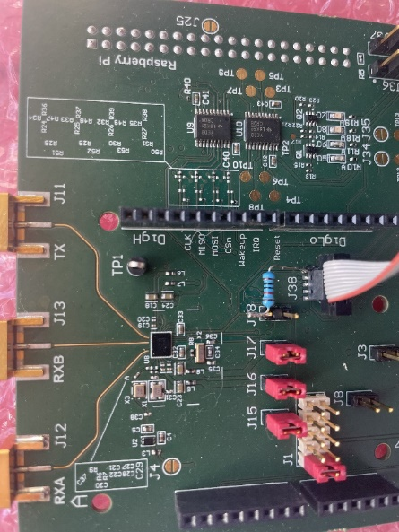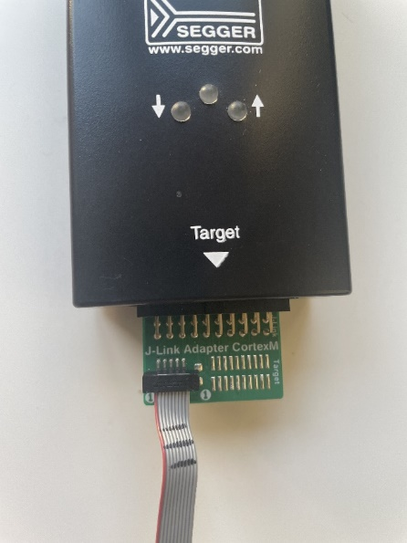
Figure 1 J-Link Connection
- Power-up QM35 EVB board using USB-C connector
- Open J-Flash Lite and select QM35720 and click OK
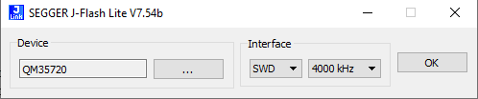
Figure 2 J-Flash Lite QM35720 Selection
- Then select the HEX data file to program and click “Program Device”
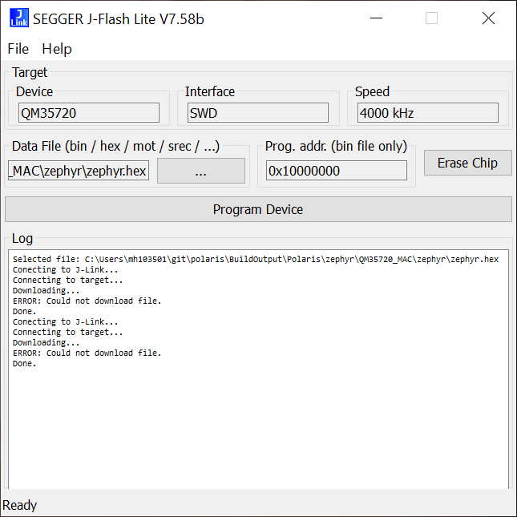
Figure 3 J-Flash Lite Programming

UART Connection
There are two UARTS on the QM35 EVB, UART0 and UART1. UART1 is the main communication interface to the QM35, it is used to communicate with the application. UART0 provides Zephyr kernel logs. The pictures below show which pins to connect a standard USB to UART cable to and the serial port settings that should be used from a serial terminal software such as PuTTY or TeraTerm.
UART0 can be found in J23.9 (Tx) and J23.10 (Rx) - Zephyr Kernel Log
UART1 can be found in J23.12 (Tx) and J23.13 (Rx) - Application Log
GPIO | Function
4 | SPI3_CS | I2C0_SDA
5 | SPI3_CLK | I2C0_SCL
6 | SPI3_MISO | UART0_TX
7 | SPI3_MOSI | UART0_RX
8 | Free pad
9 | UART1_TX
10 | UART1_RX
11 | LED_0
12 | LED_1
13 | LED_2
14 | N/A
15 | SE_WAKEUP
16 | WIFI_COEX_1
20 | RF_CTRL1 (UWB_TX)
21 | RF_CTRL2 (UWB_RX)
29 | WIFI_COEX_2
Figure 4 GPIO Function
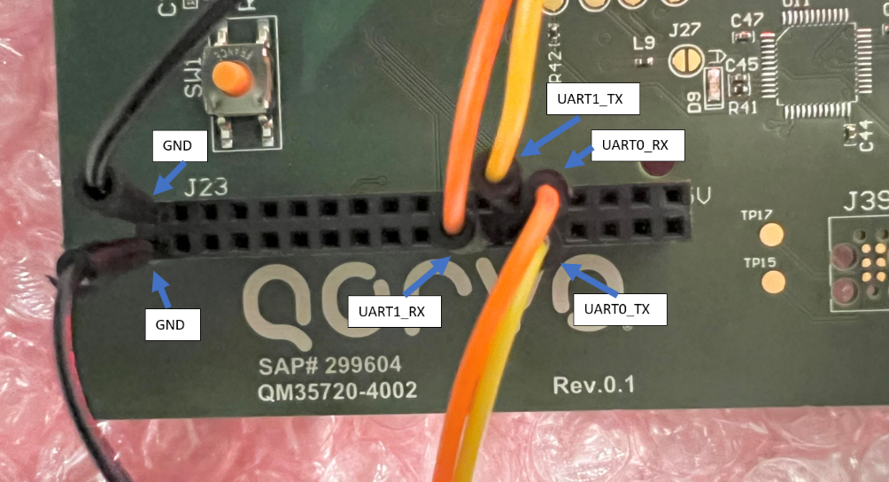
Figure 5 UART Connections
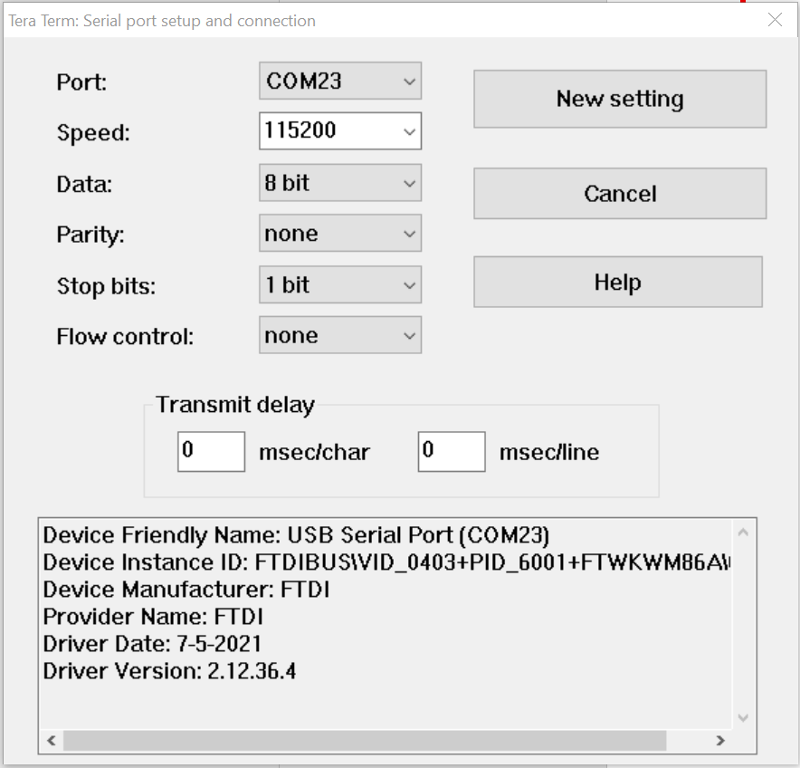
Figure 6 Serial Port Settings

Command Menu
The command menu is displayed with the help or ? commands. The menu lists the available commands.
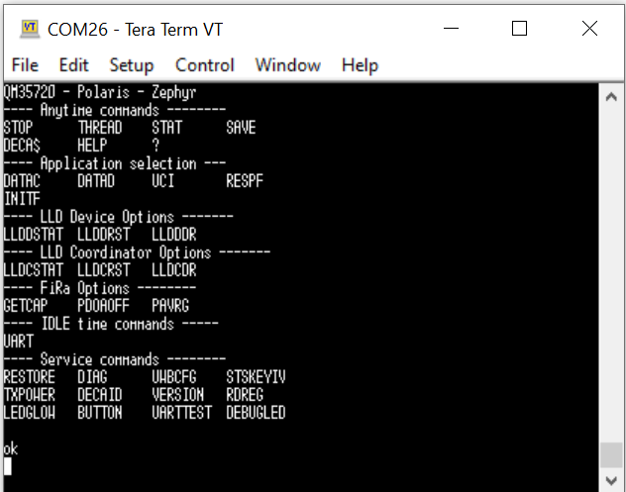
Figure 7 Command Menu
Type help and the command name to get detailed information on the command.
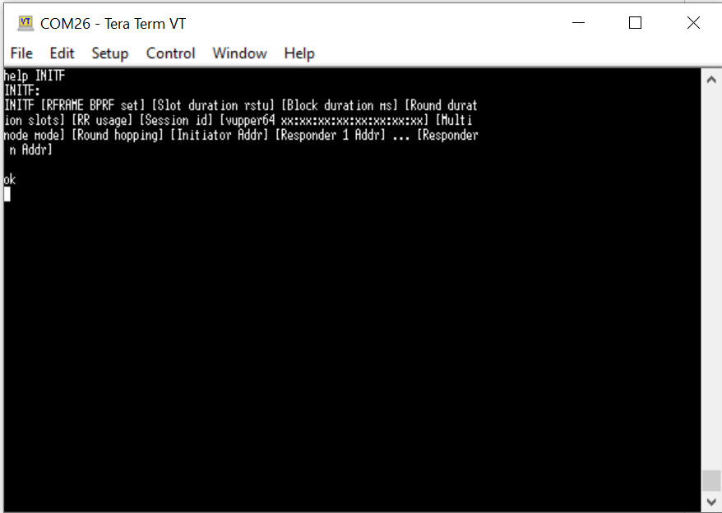
Figure 8 Help Command Information

Low Latency Data

Low Latency Data Transfer – using Internal App
The internal application is triggered through commands DATAD and DATAC. DATAC and DATAD command options can be seen below. If an option is not specified, then the default will be used.
There are 3 modes of operation. The first is Ping Pong Mode which is specified with -PP option; this transmits a payload back and forth, incrementing the payload counter each round. The second mode is TX only mode, specified with -TX, where the device transmits a payload, the coordinator receives the payload, and as soon as the transmission is complete the device sends the next payload until the specified transmissions are reached. The third mode is if neither of the two modes are specified then the two devices will connect and no payload will be transmitted but empty packets will be exchanged.
static const char DATAC_CMD_COMMENT[] = {
"DATAC [option1] [Option2] ...\r\n"
"Options:\r\n"
" -CH=9 --> Channel selection (default is 9)\r\n"
" -ANT=1 --> Antenna selection bitfield (default is 1)\r\n"
" bit0=RXA, bit1=RXB, bit2=Diversity\r\n"
" -DEV=11[,12] --> Device Address(es)\r\n"
" 2nd device is optional\r\n"
" -DR=31200 --> Data bit rate in kbps (default is 31200, \r\n"
" possible values are 850, 6810, 27200, 31200, 54000)\r\n"
" -STAT=1000 --> Display statistics every 1000 rounds(default 0)\r\n"
" -DISP=256 --> Display RX or TX message every 256 (default 256)\r\n"
" -PAYLEN=75 --> Payload length (default 75)\r\n"
" -PLEN=64 --> Preamble length (default 64, select either 32 or 64)\r\n"
" -SLOT=400 --> Slot duration in RSTU (default 400 RSTU <-> 333 us)\r\n"
" -BLOCK=2400 --> Block duration in RSTU (default 2400 RSTU <-> 2 ms)\r\n"
" -RETRY=1 --> Number of Retry Sub-blocks (default 1)\r\n"
" -PP=100 --> Enter PingPong mode for 100 LoopBack\r\n"
" -RSSI=0 --> Append RSSI result(default is 0)\r\n"
};
static const char DATAD_CMD_COMMENT[] = {
"DATAD [option1] [Option2] ...\r\n"
"Options:\r\n"
" -CH=9 --> Channel selection (default is 9)\r\n"
" -ANT=1 --> Antenna selection bitfield (default is 1)\r\n"
" bit0=RXA, bit1=RXB, bit2=Diversity\r\n"
" -ADDR=11 --> Device address(Default is 11)\r\n"
" -STAT=1000 --> Display statistics every 1000 rounds(default 0)\r\n"
" -DISP=256 --> Display RX or TX message every 256 (default 256)\r\n"
" -PAYLEN=75 --> Payload length (default 75)\r\n"
" -PLEN=64 --> Preamble length (default 64, select either 32 or 64)\r\n"
" -DR=31200 --> Data bit rate in kbps (default is 31200, \r\n"
" possible values are 850, 6810, 27200, 31200, 54000)\r\n"
" -PP=100 --> Enter PingPong mode for 100 LoopBack\r\n"
" -TX=100 --> Enter TX only mode for 100 iterations\r\n"
" -RSSI=0 --> Append RSSI result(default is 0)\r\n"
};

LLD statistics can be reset using the LLDDRST/LLDCRST commands for device/coordinator respectively while the device/coordinator are running.
LLD statistics can be printed out while the device/coordinator are running periodically using the –STAT option or on demand with the LLDDSTAT/LLDCSTAT, respectively.

TX Demo, single side transmission
Type DATAD -TX=10000 on one board to start the device in TX mode
Type DATAC on the other board to start the coordinator
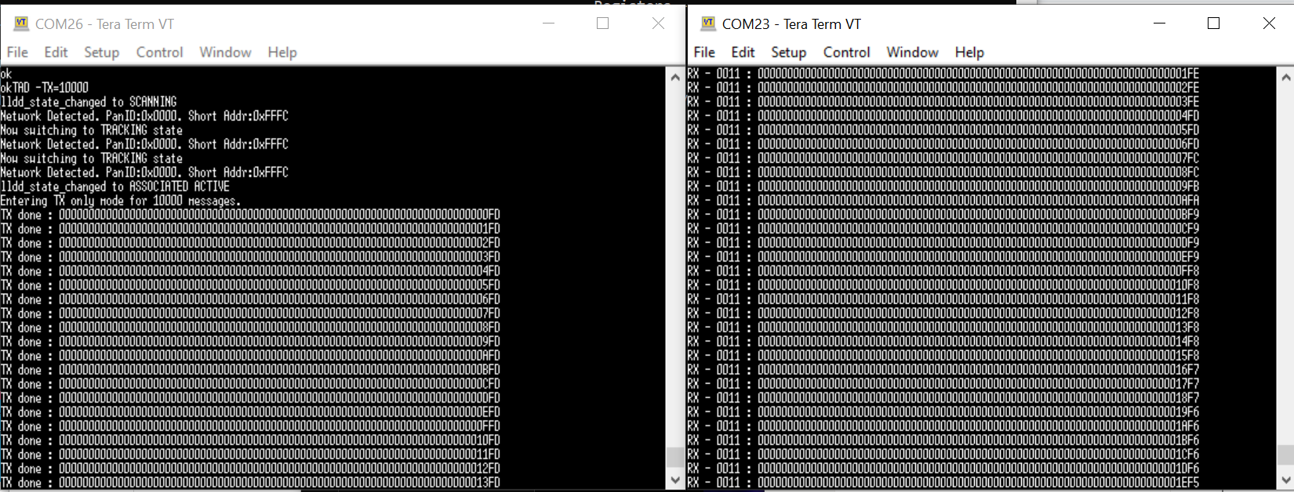
Figure 9 Single side TX Demo
The number of digits displayed corresponds to the payload length.
Boards will display statistics and go back to IDLE state at the end of the test.
You can swap the TX option and have DATAC -TX=10000 and DATAD

TX Demo, dual side transmission
Type DATAD -TX=10000 on one board to start the device in TX mode
Type DATAC -TX=10000 on the other board to start the coordinator
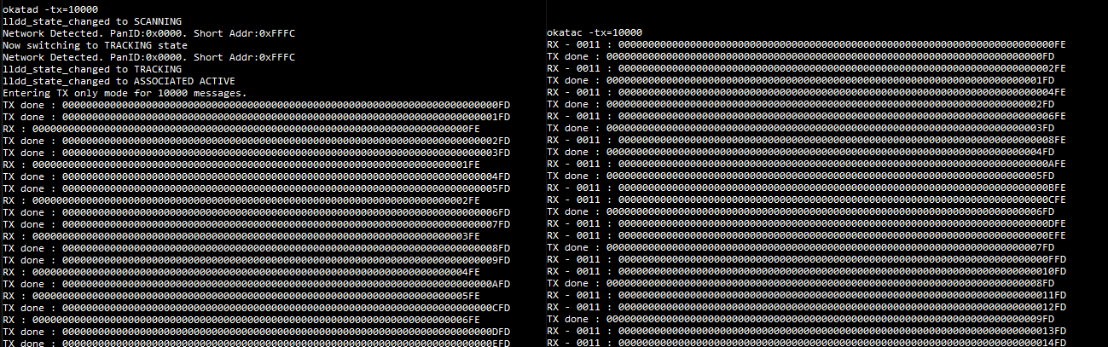
Figure 10 Dual side TX Demo

Both boards will do TX and RX at the same time
The number of digits displayed corresponds to the payload length.
Boards will display statistics and go back to IDLE state at the end of the test.

TX Demo with Two Devices
Type DATAD -TX=10000 on one board to start the first device in TX mode
Type DATAD -TX=10000 -ADDR=12 on the second board to start the second device in TX mode
Type DATAC on the third board to start the coordinator
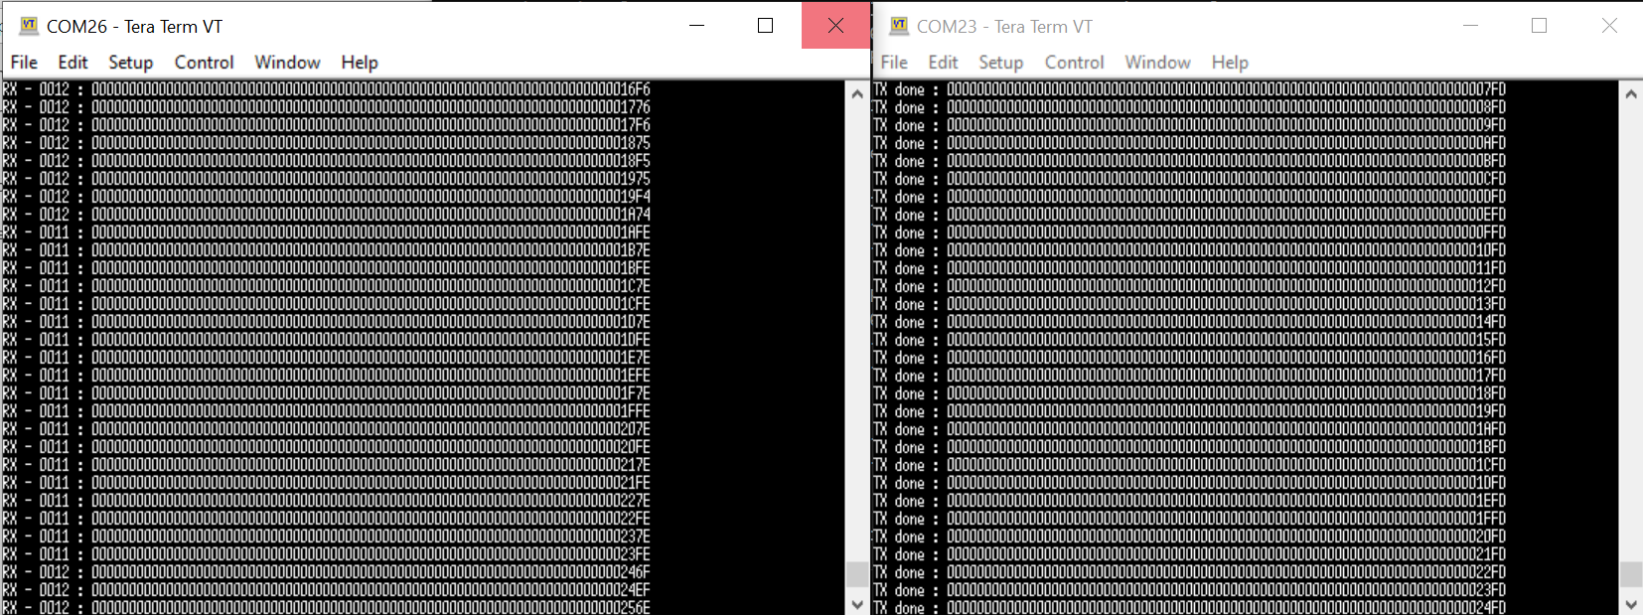
Figure 11 Two Device TX Demo
Boards will display statistics and go back to IDLE state at the end of the test.

Connection without Data Transfer Demo
Type DATAD on one board to start the device
Type DATAC on the other board to start the coordinator
Type LLDDSTAT on the device to display statistics
Type LLDCSTAT on the coordinator to display the statistics
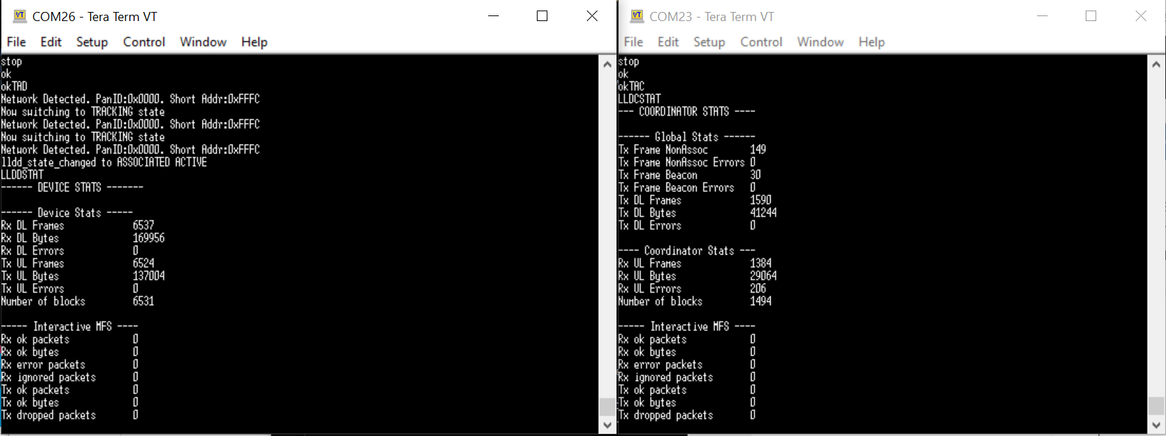
Figure 12 Connection Without Data Transfer

Frame Structure Modifications
It is possible to change the slot and block durations from the DATAC command line options. If additional changes are desired, then most of the frame structure is specified in struct static data_transfer_param_t data_param in data_transfer_app.c for DATAD/DATAC mode. These default values can be modified to test different frame structures. The below table details the more important values.
Parameter | Unit | Description
.network.blockRstu | 1/833.33ns | Block Duration
.network.sbDlSlotRstu | 1/833.33ns | Downlink Slot Duration
.network.sbMinRstu | 1/833.33ns | Minimum sub-block duration
.network.sbRetryMax | 1/1 | Number of Retry Sub-blocks
.network.sbUlSlotLastRstu | 1/833.33ns | Last Uplink Slot Duration
.network.sbUlSlotRstu | 1/833.33ns | Uplink Slot Duration

Low Latency Data Transfer – using UCI
When the board is booting after a download, it will start in default monitor mode. Therefore, you will need to switch the command interpreter to have the board entering UCI protocol mode.
Step 1: Enter UCI protocol mode
- Send command UCI
- The device will return “ok” before switching to UCI protocol
- If you want to have the board booting in UCI protocol on subsequent powerup, send SAVE
- If you want to revert to default ASCII protocol, send STOP. You can additionally send SAVE again to save the default protocol into flash
- We implemented a backdoor over the UCI protocol to support the SAVE and STOP commands
- Disconnect your terminal to release the COM port
- Known issue: After sending SAVE, you will need to power cycle the board

Step 2: Preparing the UCI test
- Unzip the file containing python scripts

Step 3 : Testing the UCI in Coordinator mode
Step3A: setup the DEVICE board
- On the board not set to operate in UCI mode send DATAD -DR=6810
- This board will act as a DEVICE. Since you did not send any parameter, it will not initiate a data transfer like what we did in the internal App demo

Step3B: initiate UCI test on the COORDINATOR board
- Open a command prompt and run on the other board (connected to COM5 for example)
  - python uci_test_data_transfer.py -p COM5
- the test will send a set of UCI commands to setup the board to operate in COORDINATOR mode
- The script will send some packets for 10 seconds
- You will see 2 types of notifications in blue.
  - The 1st one starting by notif: 0xa 0xa… will arrive when the TX done message will be sent by the MAC
  - The 2nd one starting by notif: 0xa 0xb… will arrive when an RX message will be sent by the MAC

On the DEVICE side you should see 10 messages like this:
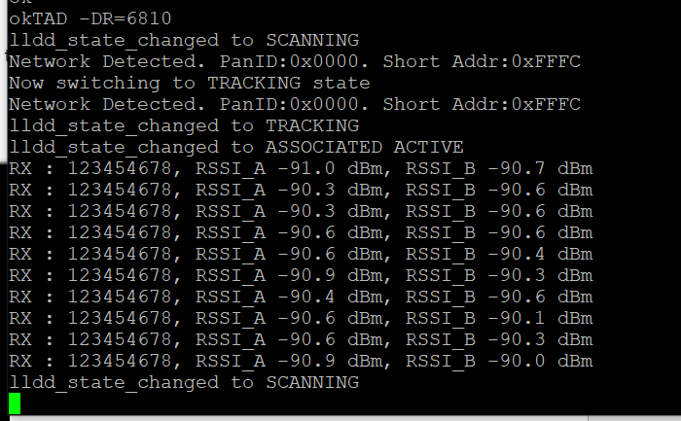

On the COORDINATOR side, you will see messages like this:
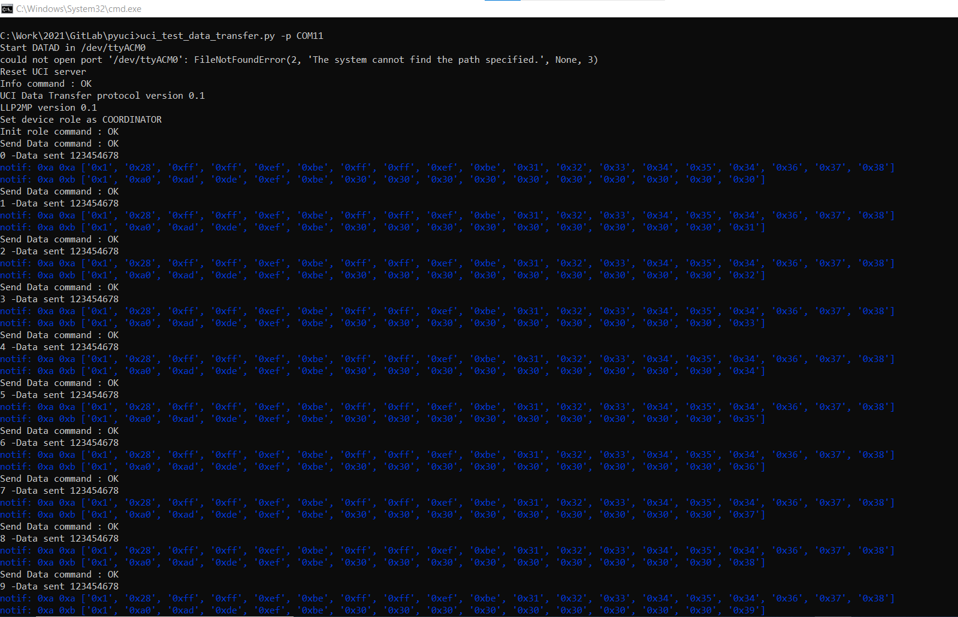
The error message is expected in that case because the script can also initiate the DATAD operating mode on the other board, but to make the screen shot above we start the DEVICE board manually.
The script will automatically reset the board running the UCI server at the end of the test.
On the board running the application, you will need to send STOP command to start a new test

Application-Application Latency Testing
Several GPIOs are used to test the latency between EVBs.
GPIO11 will go high at start MAC TX ingress and go low at MAC TX complete.
GPIO12 will go high at MAC RX and go low at Application ingress.
The time difference between the TX/RX GPIOs toggling high is the device/coordinator application to application latency.

Time Synchronization Testing
The ping pong demo above includes a time synchronization demo. Every 16th ping pong a sync message is transmitted from the coordinator to the device to toggle GPIO13 at an absolute time in the future. The time difference between device and coordinator GPIO13 falling edge is the timing difference between devices. Below further explains what happens on the coordinator/device and logic analyzer screen captures are included with current results.
On the Coordinator:
The coordinator sends a sync command to the device with an absolute time in the future (local time + TIMER0_CNT time). When this packet is queued up for transfer by the coordinator the coordinator starts it's timer0 for TIMER0_CNT in the future and set GPIO13 high. When the timer expires GPIO13 is driven low.
On the Device:
When the device receives the sync time it starts it's timer by calculating the timer time counts in the future by taking the absolute time transmitted – network time; where network time equals device local time - network time offset. A small offset is also subtracted to account for the time lost from reading the time and starting the timer. When the timer is started GPIO13 is driven high. When it expires GPIO13 is driven low.
See the following files for implementation:
data_transfer_app.c
data_transfer_coordinator.c
data_transfer_device.c

Start of Data Transfer
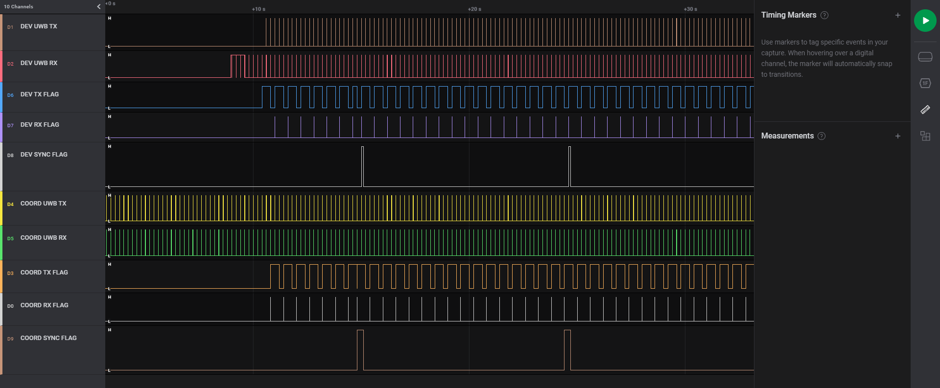
Sync on falling edge
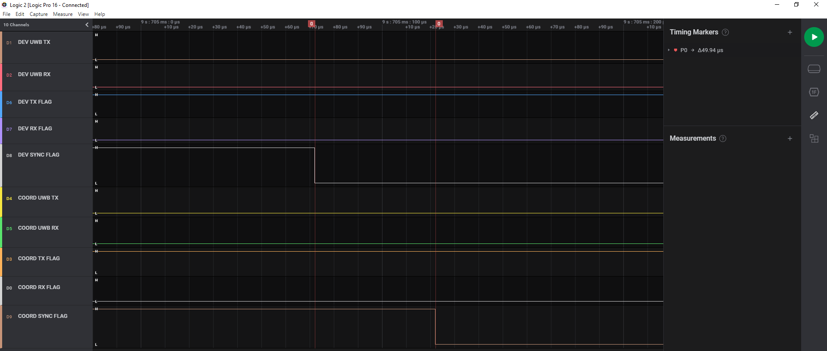
Known issue: On A0 silicon, time sync is interrupt dependent. We subtract a given number of cycles to the programmed timer to compensate this. We noticed after packaging that the latest optimizations reduced this timing, thus we compensate too much by 50us.

End of UWB to start to entry in APP layer
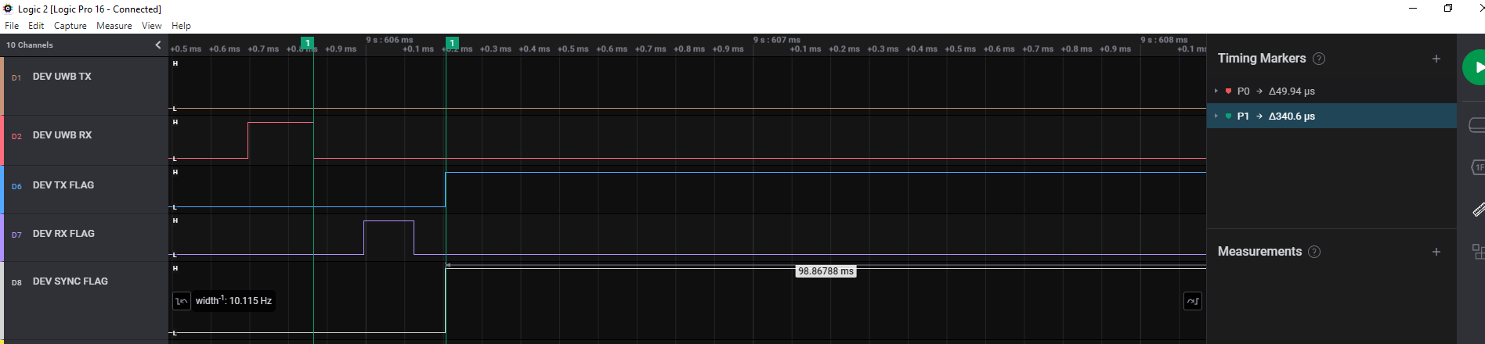
To be improved in B0 and later version

Statistics Information
/* LLD global coordinator statistics */
Tx Frame NonAssoc - Number of non associative frames successfully transmitted.
Tx Frame NonAssoc Errors - Number of non associative frames not transmitted.
Tx Frame Beacon - Number of beacon frames successfully transmitted.
Tx Frame Beacon Errors - Number of beacon frames not transmitted.
Tx frame Errors - Number of frames not transmitted.

/* LLD coordinator statistics */
Rx UL Frames - Number of good UL frames received.
Rx UL Bytes - Number of good UL frames bytes received, FCS not included
Rx UL Errors - Number of UL frames received with error, or not received.
Tx DL Frames - Number of DL frames transmitted successfully.
Tx DL Bytes - Number of DL frame bytes transmitted successfully
Tx DL Errors - Number of DL frames transmitted but not acknowledged.
Number of blocks - Number of blocks in which the device participated (tracking or associated).

/* LLD coordinator Interactive MFS statistics */
Rx ok packets - Number of good data packets received
Rx ok bytes - Number of good received bytes, corresponding to rx_packets.
Rx error packets - Number of bad data packets received.
Rx ignored packets - Number of good data packets ignored because they are out of the reception window.
Tx ok packets - Number of packets successfully transmitted by the coordinator.
Tx ok bytes - Number of transmitted bytes, corresponding to tx_packet.
Tx dropped packets - Number of data packets dropped before successful transmission.

/* LLD coordinator Best Effort MFS statistics */
Rx ok packets - Number of good data packets received
Rx ok bytes - Number of good received bytes, corresponding to rx_packets.
Rx error packets - Number of bad data packets received.
Rx ignored packets - Number of good data packets ignored because they are out of the reception window.
Tx ok packets - Number of transmitted bytes, corresponding to tx_packet.
Tx ok bytes - Number of transmitted bytes, corresponding to tx_packet.
Tx dropped packets - Number of data packets dropped before successful transmission.

/* LLD device statistics */
Rx DL Frames - Number of good DL frames received
Rx DL Bytes - Number of good DL frames bytes received
Rx DL Errors - Number of DL frames received with error
Tx UL Frames - Number of UL frames transmitted successfully
Tx UL Bytes - Number of UL frames bytes transmitted successfully
Tx UL Errors - Number of UL frames transmitted with error.
Number of blocks - Number of blocks in which the device participated (tracking or associated).

/* LLD device Interactive MFS statistics */
Rx ok packets - Number of good data packets received.
Rx ok bytes - Number of good received bytes
Rx error packets - Number of bad data packets received.
Rx ignored packets - Number of good data packets ignored because they are out of the reception window.
Tx ok packets - Number of data packets successfully transmitted (acknowledged successfully or no acknowledgement required).
Tx ok bytes - Number of transmitted bytes
Tx dropped packets - Number of data packets not transmitted due to problem with the packet.

/* LLD device Best Effort MFS statistics */
Rx ok packets - Number of good data packets received.
Rx ok bytes - Number of good received bytes
Rx error packets - Number of bad data packets received.
Rx ignored packets - Number of good data packets ignored because they are out of the reception window.
Tx ok packets - Number of data packets successfully transmitted (acknowledged successfully or no acknowledgement required).
Tx ok bytes - Number of transmitted bytes
Tx dropped packets - Number of data packets not transmitted due to problem with the packet.

Low Latency Data Transfer - source code organization

Key files on application side
Files common to Internal App And UCI:
\Src\Apps\Src\data_transfer\data_transfer_common.c
Files Specific to Low Latency Data Transfer Internal App:
\Src\Apps\Src\data_transfer\data_transfer_device.c
\Src\Apps\Src\data_transfer\data_transfer_coordinator.c
\Src\Apps\Src\data_transfer\data_transfer_fn.c
\Src\Apps\Src\data_transfer\data_transfer_app.c
Files Specific to Low Latency Data Transfer UCI:
\Src\Apps\Src\uci\task_uci\uci_llp2mp.c

Key files on the MAC side
\Libs\uwbstack\uwbstack_src\uwbmac\src\lldc_helper.c
\Libs\uwbstack\uwbstack_src\uwbmac\src\lldd_helper.c
\Libs\uwbstack\uwbstack_src\mac\lld_common.h

TX Power Setting
The default TX power is 0xFDFDFDFD. This is a 32-bit register setting which follows the same properties as the TX_POWER register on the DW3000. Each octet controls the TX power across the 4 different fields (data, header, synchronization, and STS) in the TX packet. Typically it is recommend keeping the same value for each of these fields and hence this is why 0xFD is repeated 4 times in the default power setting. Below are some example values and their relative gain difference to the default power setting. Each of the values in the table are lower than the default. Step sizes can vary between ICs. You can record the exact gain difference for a specific device through a spectrum analyzer.
Setting | Gain Difference to 0xFDFDFDFD (dB)
0xFDFDFDFD | Default value
0xC9C9C9C9 | 1.04
0xA9A9A9A9 | 2.07
0x8D8D8D8D | 2.97
0x79797979 | 4.00
0x69696969 | 5.00
0x35353535 | 10.02
0x1D1D1D1D | 14.93
0x0D0D0D0D | 20.98

To change the TX power, the txpower command should be used.
TXPOWER:
Tx Power settings.
Usage: To see Tx power "txpower". To set the Tx power "tx power 0x<POWER_HEX> 0x<PGDLY_HEX> 0x<PGCAL_HEX>"
For example, to reduce the TX power by 5dB from the default value (i.e., going from 0xFDFDFDFD to 0x69696969), you can use the command txpower 0x69696969 0x34 0x0.
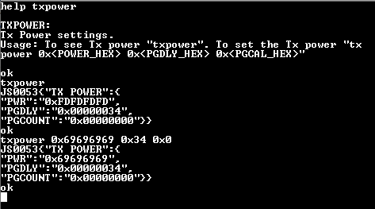
Figure 13 Power Setting
More information about the register settings for the TX_POWER register can be found on p. 106 of the DW3000 User Manual or in DW3000_Tx_Power.xlsx.

RSSI Reports
If RSSI measurements are desired, then type DIAG 1 prior to enabling FiRa ranging or use the -RSSI=1 option when using DATAC/DATAD. RSSI values will be printed for both RXA and RXB ports. The DIAG 1 command only needs to be entered after power on.
An offset correction needs to be applied to these RSSI measurements to get the true received signal power level as instructed in PER_and_RSSI_Measurements_with_QM3572x_Rev0.pdf.
The below screenshots contain examples for the RSSI measurement on RXA (RSSI_A). Note that the RXB port did not have an antenna connected so the RSSI_B measurement was –inf.
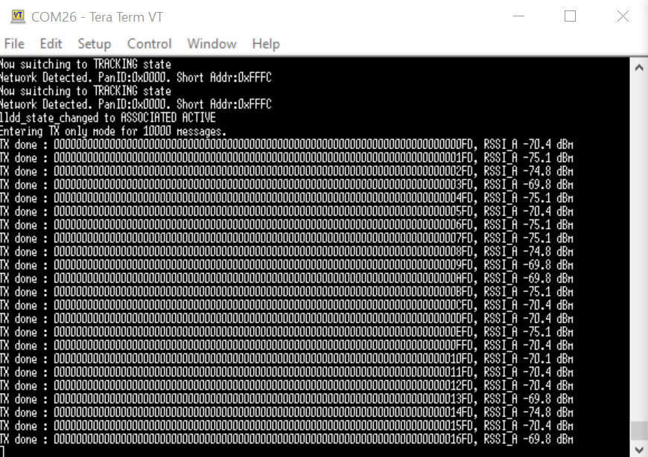
Figure 14 RSSI measurements in Data Transfer app
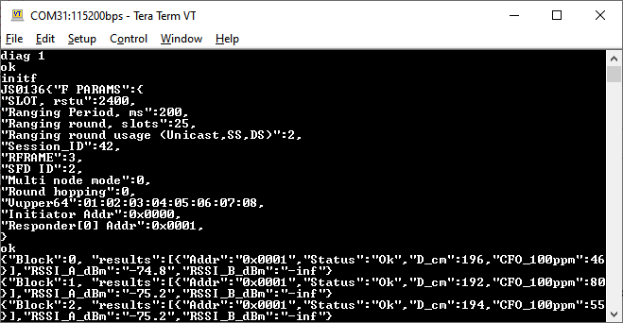
Figure 15 RSSI measurements in FiRa app

FiRa

Initiating FiRa ranging
Type command INITF on one board and RESPF on the other board.
You will see ranging message like this:
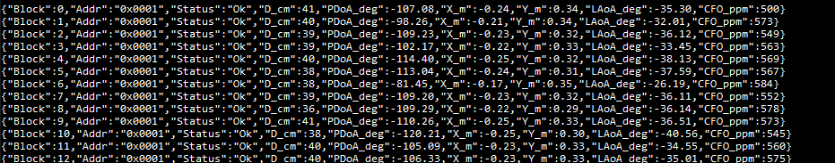
Figure 16 FiRa Ranging Output
The Output is in JSON format
- Block: the Ranging Round number
- Addr: Address of the device
- Status: Displays “Ok” when the ranging was successful
- D_cm: Distance in centimeters between the 2 boards
- PDoA_deg: phase difference of arrival
- X_m: distance on X axis
- Y_m: distance on Y axis
- LAoA: Angle of arrival
- CFO_ppm: clock frequency offset applied

Initiating FiRa ranging with Data Transfer
Please note that this method is not FiRa Compliant.
There are some discussions in FiRa committee to define a standard method for adding the data transfer capability over FiRa.
The method currently used is subject to change based on FiRa spec update

In this release, the data transferred over FiRa is a fixed pattern.
You can modify this in the source code.
See data_params in fira_app.c
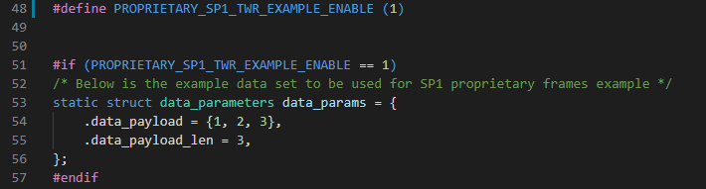
Figure 17 FiRa Data Transfer Payload

To initiate a FiRa Transfer with Data Payload, you need to call INIT and RESPF with optional parameter 1 set to 3
Send command INITF 3 on one board and RESPF 3 on the other board.
You will see ranging message like this:
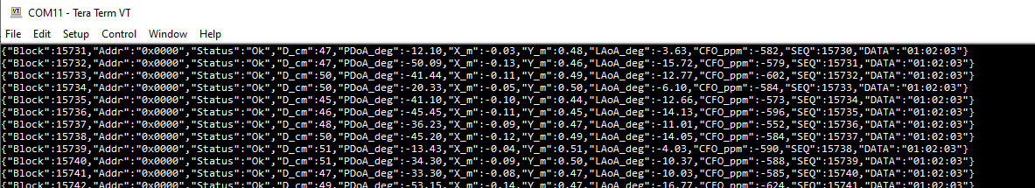
Figure 18 FiRA Ranging with Data Transfer

Two additional fields are added to the JSON output
SEQ: a block counter
DATA: data that was transferred

UCI and FiRa Ranging
When the board is booting after a download, it will start in default monitor mode. Therefore, you will need to switch the command interpreter to have the board entering UCI protocol mode.
Step 1: Enter UCI protocol mode
- Send command UCI
- The device will return ok before switching to UCI protocol
- If you want to have the board booting in UCI protocol on subsequent powerup, send SAVE
- If you want to revert to default ASCII protocol, send STOP. You can additionally send SAVE again to save the default protocol into flash
- We implemented a backdoor over the UCI protocol to support the SAVE and STOP commands
- Disconnect your terminal to release the COM port

Step 2: Preparing the UCI test
- Unzip the file containing python script

Step 3A : Testing the UCI in Controller mode
- On one board send RESPF
- Open a command prompt and run on the other Board (connected to COM5 for example)
  - Uci_test.py -p COM5
- The UCI test script starts a FiRa ranging
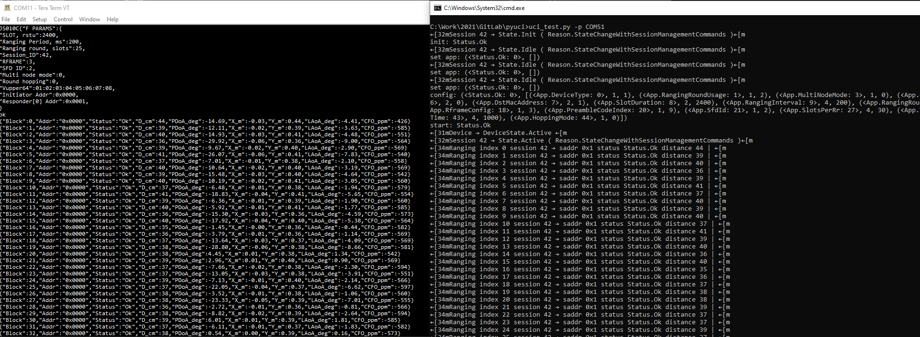
Figure 19 FiRa Ranging

Step 3B: Testing the UCI in Controlee mode
- On one board send INITF ASCII command
- Open a command prompt and run on the other Board (connected to COM5 for example)
  - Uci_test.py -p COM5 --controlee
- The UCI test script starts a FiRa ranging

Visualizing UCI packets sent over USB
Open core.py and set debug = True at line 4
You will see those extra data
